**Small Caps**

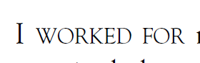

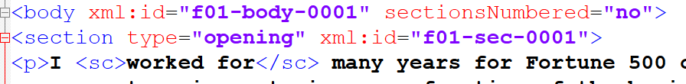

**Chapter linking**

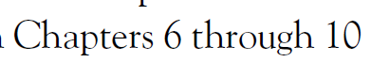



**Dedication**

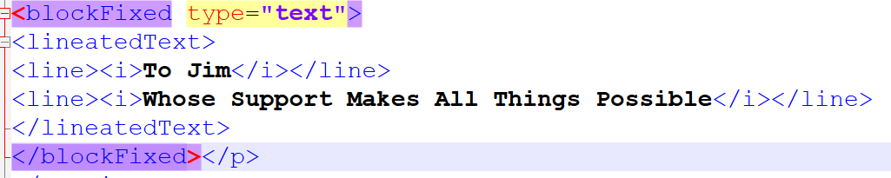

**URL**



**Blockfixed**

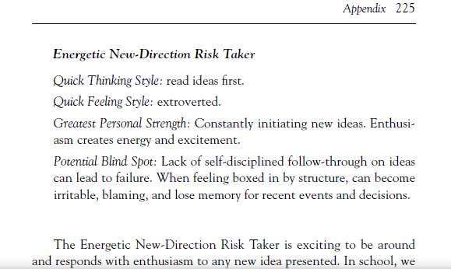

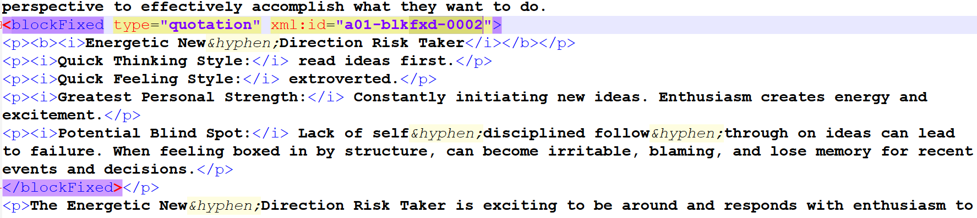

**Figure Link**

